Curriculum Vitae
Personal Data:
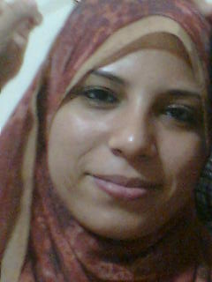
Name: Samar Thabet Abu Bakre
Sex: Female
Date of birth: 9/2/1985
Marital status: married
Telephone numbers:
Home:
Mobile:01067449485

E mail :samarthabet@med.sohag.edu .eg
Address of correspondance:

Qualifications

Current position
.

Careers
Assistant lecturer in Aneasthesia and ICU and Pain management in sohag university

Academic Experience:

Western qualifications and experience:

Administration experience:

- Publications

Conferences attended

Workshops attended
- Scientific day of vertigo.on18 feb 2012.
- First aid management in airway on16-8-2014.
- Annual national conference of sohag faculty of medicine ,sohag university on third and fourt May 2014
- Advanced life support course of airway management and initial assessment and resuscitation in cardiac arrest on 2-3-2013
- First international conference of pain management faculty of medicine ,sohag university 29jan-first feb 2016
- First UEU2017 conference first national urology conference of upper Egypt universities in callobaration with EUA ON 7-10 Feb 2017
- Therteen Annual scientific conference on 1-3 April 2014
- Workshop in thorathic anaesthesia in fifth all Africa anaesthesia congress on 6-10 april 2013
- 5th ALL AFRICA ANAESTHESIA CONGRESS ON 6-10 APRIL 2013.
- 16TH ALEXANDRIA ANEASTHSIA INTENSIVE CARE CONFERENCE ON 2-4 OCTOBER 2012.
- SECOND ANNUAL NATIONAL CONFERENCE OF PAIN SOHAG FACULTY OF MEDICINE SOHAG UNIVERSITY.
- Surgical Hearing Implant Academy Module 2 of the Vibrant MED-EL held at Innsbruck, Austria on 3/11/2015

